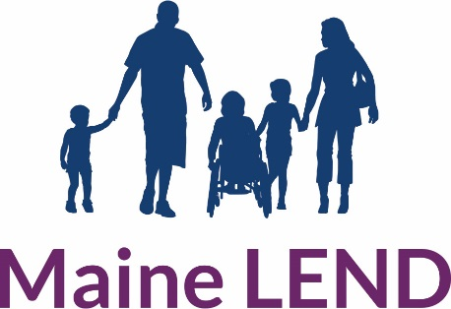

Maine Leadership Education in Neurodevelopmental and

Related Disabilities (LEND) Program

Trainee Application
Directions for Applicants
- Self-Advocate and Family applicants please contact Dr. Audrey Bartholomew to begin your application process: abartholomew1@une.edu
- Complete the application below including typed, narrative responses to application questions.
- Please provide us with a current resume or curriculum vitae (CV).
- Provide name and contact information for three people who can attest to your professional, interpersonal, and/or leadership skills. References are waived for current UNE students.
  - E-mail a completed application, resume/CV, and reference contacts to Dr. Audrey Bartholomew, Maine LEND Training Director, at abartholomew1@une.edu
- Professionals and non-UNE student applicants should request official transcripts be sent from your current or prior program of study to:
Maine LEND Program Admissions
Attn: Lianne Lissauer
716 Stevens Avenue
Portland, ME 04103

Today’s Date: Click or tap to enter a date.

Contact Information

Full Name: _________________________
Local Address: _________________________
Phone: _________________________
E-mail Address: _________________________
Credentials (if applicable): _________________________

Please check the applicable graduate student or pre/post-professional trainee discipline:
☐ Audiology
☐ Nursing
☐ Occupational Therapy
☐ Physical Therapy
☐ Public Health
☐ School Psychology
☐ Social Work
☐ Special Education
☐ Speech Language Pathology
Other Disciplines:
☐ Family Discipline
☐ Self-Advocate Discipline

Highest level of education:
☐ High School
☐ Associates Degree
☐ Bachelor’s Degree
☐ Graduate Degree
☐ Doctoral Degree
☐ Other: Click or tap here to enter text.

Please answer the questions below concisely in paragraph form. Please limit your total responses to no more than the equivalent of two pages, double-spaced, in 12-point font.
LEND is committed to being inclusive. If you would like assistance with completing this application, Dr. Audrey Bartholomew is happy to help at (207) 602-2685.

- Why are you interested in working with and helping people with neurodevelopmental disabilities and their families?

- Describe any experience, service-related or volunteer work in which you have been involved with people with neurodevelopmental disabilities.

- What do you hope to achieve personally and professionally from this LEND traineeship with respect to people with neurodevelopmental disabilities?

- Do you currently reside in the State of Maine? If not, how did you learn about the Maine LEND Program? Do you intend to live and work in the State of Maine in the future?

